**Dan Otieno**

**EE 316 Lab 3: Pre-Lab Assignment.**

**Due date: 09/11/22.**

**Assignment details:**

Read Lab 3 manual and calculate output voltage for figure 3.2 given the following conditions:

R = 1 ohm.

C = 1 F.

Vin = sin(t).

Given the figure below:

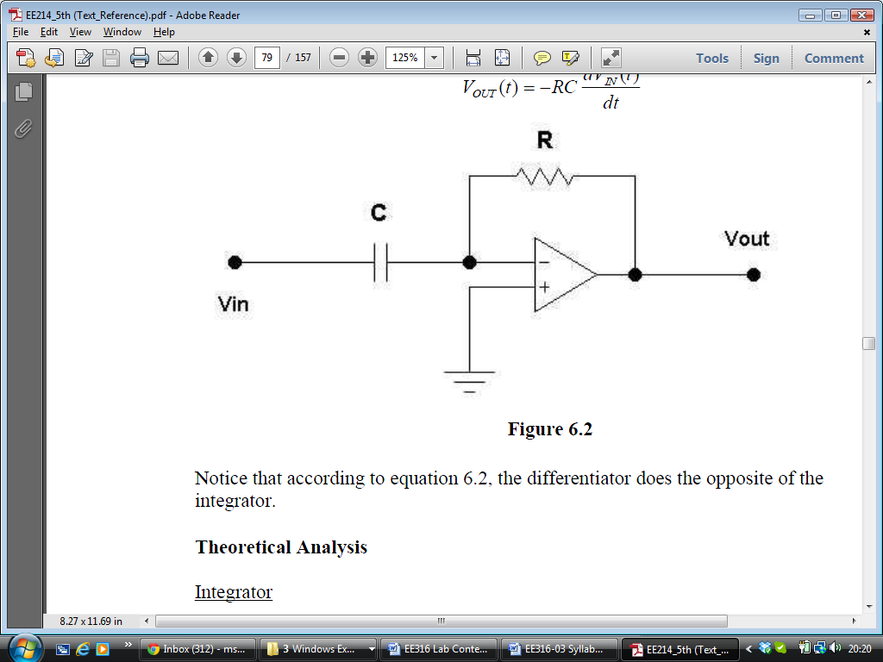

We know that:

